InterfaceLoader v3 Features

Author: Tanya Leonce

Contents

New Excel Layout Template File 4

Run InterfaceLoader v3 To Generate BuildDriverTable Code 4

U_dsi_SQLCode Tab – New Features 5

Notes 5

Template Name 6

Audit Code 6

BDM Code 6

BDM Code Notes 6

Working Tables 7

Working Table Notes 7

FileName 8

FileName Notes 8

Scheduled Job Script 9

FileName Notes 9

U_dsi_FieldDefs Tab – New Features 10

Notes 10

U_dsi_Configuration Tab – New Features 11

Notes 11

Notes (Continued) 12

U_dsi_SQLClauses Tab – New Features 13

Notes 13

U_dsi_AuditRecs – New Tab and Features 14

Sample Excel File 14

Sample Auto-Generated Code 15

U_dsi_BDMConfigs – New Tab and Features 16

Sample Excel File 16

Sample Auto-Generated Code 17

# New Excel Layout Template File

The Excel File Layout Template is the main file you will be configuring to use with the InterfaceLoader v3. The Filename is setup as "FormatCode Layout.xls". You will need to change the "FormatCode" to match the New FormatCode (i.e., ESAMPLE) you created for the Custom Interface.

For Example:

* FormatCode = ‘ESAMPLE’
* FileName = ‘ESAMPLE Layout.xls"

The Excel file extension "XLS" is supported. You have to have a space between the "FormatCode" and "Layout.xls".

The InterfaceLoader_v3 is setup to use the switchbox_v2 functionality and will work with both UltiPro Web and UltiPro BackOffice products.

# Run InterfaceLoader v3 To Generate BuildDriverTable Code

A stored procedure was setup to use to execute the InterfaceLoader_v3 process. The Stored Procedure makes the necessary calls to the set of stored procedures related to the InterfaceLoader_v3.

You will need to specify the Folder Name in the dsi_sp_InterfaceLoader_v3 Stored Procedure. To execute/start the InterfaceLoader_v3 Process using the Script Below:

EXEC dbo.dsi_sp_InterfaceLoader_v3 @FormatCode = 'ESAMPLE', @Name = 'Tanya';

# U_dsi_SQLCode Tab – New Features

The first tab in the Excel Layout Template File is the "U_dsi_SQLCode" Tab. By entering the FormatCode (i.e., ESAMPLE) in the [A2] Cell, which is highlighted in Yellow below. This will then auto-populate the FormatCode throughout the remainder of the file.

You should also fill out the first few fields as Descriptions of the Custom Interface you’re creating (i.e., Developer Name, BA Name, etc).

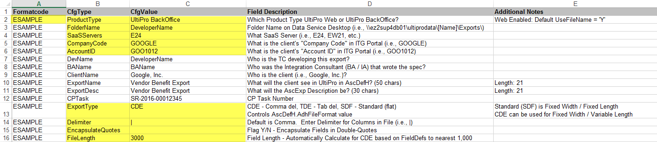

## Notes

* "FormatCode" – When populated in Column A2, it will auto-fill for the workbook. If the value is over 10 characters, then highlight in **RED**.
* "ProductType" – Options: "UltiPro Web", "UltiPro BackOffice". Values will auto-generate within the Spreadsheet designed for that product type.
* "FolderName" – This value will auto-populate the Data Services Desktop Folder in the 'ExportPath' and 'TestPath' in U_dsi_Configuration tab.
* "SaaSServers" – This value is to generate the AscExp.ExpFileName value for UltiPro Web, or the UDESPath for UltiPro BackOffice.
* "CompanyCode" – This value is to generate the AscExp.ExpFileName value for UltiPro Web.
* "AccountID" – This value is to generate the AscExp.ExpFileName value for UltiPro Web, or the UDESPath for UltiPro BackOffice.
* "ExportType" – The Standard (SDF) is rarely used, but for vendor’s requiring Fixed Width / Fixed Length, then it is required.
* "Delimiter" – For Delimited Files, then you can specify the Delimiter (i.e., Pipe = |), otherwise it will default to Comma Delimiter.
* "EncapsulateQuotes" – This feature will change the ForCond in the U_dsi_FieldDefs tab from 'T' (Trimmed) to 'Q' (Double-Quotes).
* "FileLength" – For Fixed Length (SDF), this must be exact. Otherwise, this value will auto-populate to nearest 1,000 based on U_dsi_FieldDefs.

## Template Name

If a "TemplateName" is chosen in the drop-down list, then Flags will be automatically Set for Audit, BDM, OpenEnroll, PDedHist, PEarHist.



## Audit Code

The Configuration Type = ‘Audit’ is used to provide Sample Audit Code in the BuildDriverTable stored procedure, if the Flag is Set to "Y". If the Flag is Set to "N" or Empty/Blank, then it will not populate any sample code. The U_dsi_AuditRecs Tab is used in conjunction with this Configuration Type setup.



## BDM Code

The set of Configuration Types in the below screenshot are related to the ‘BDM’ Module setup in the BuildDriverTable stored procedure.

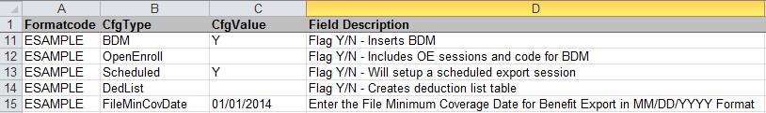

### BDM Code Notes

* "BDM"
  + If Flag is Set to "Y", then sample BDM Configuration code will be provided in the BuildDriverTable stored procedure.
* "OpenEnroll"
  + If Flag is Set to "Y", then sample BDM Open Enrollment Configuration code will be provided in the BuildDriverTable stored procedure.
  + Open Enrollment for Active and Passive Export Sessions (OEPASSIVE / OEACTIVE) will be automatically created.
* "Scheduled"
  + If Flag is Set to "Y", then SCHEDULED Enrollment Export Sessions will be automatically created.

## Working Tables

The set of Configuration Types in the below screenshot will provide sample Working Table code in the BuildDriverTable stored procedure.



### Working Table Notes

* "PDedHist"
  + If Flag is Set to "Y", then sample Working Table code will be provided in the BuildDriverTable stored procedure for PDedHist table.
* "PEarHist"
  + If Flag is Set to "Y", then sample Working Table code will be provided in the BuildDriverTable stored procedure for PEarHist table.

## FileName

The set of Configuration Types in the below screenshot are related to the FileNames setup in the BuildDriverTable stored procedure when updating U_dsi_Parameters table with the ExportFile value.



### FileName Notes

* "FileName"
  + If this field is populated, then the Production Filename will be setup in the BuildDriverTables stored procedure.
* "TestFileName"
  + If this field is populated, then the Test Filename will be setup in the BuildDriverTables stored procedure.
  + The Test Filename is used when the Export Session "TEST" has been executed, otherwise it defaults to the Production Filename.
* "OEFileName"
  + If this field is populated, then the OE Filename will be setup in the BuildDriverTables stored procedure.
  + The OE Filename is used with the Open Enrollment Export Sessions have been executed (OEPASSIVE/OEACTIVE) only.

## Scheduled Job Script

The set of Configuration Types in the below screenshot are will provide sample code that will Create a Scheduled Job automatically. The sample code can be found in the Comments section at the very end of the BuildDriverTable stored procedure.

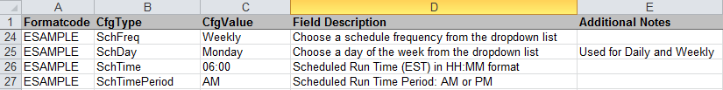

### FileName Notes

* "SchFreq"
  + This field is the File Scheduling Frequency, which is a drop-down list that provides the following options: **Daily, Weekly, Bi-Weekly, Monthly**
* "SchDay"
  + This field is the File Scheduling Frequency, which is a drop-down list that provides the following options: **Monday, Tuesday, Wednesday, Thursday, Friday**.
  + This field is used in conjunction with the "SchFreq" field.
  + If "SchFreq" is set to "Monthly", then this field should remain Blank/Empty. The Schedule Job will default to the 1st of the Month.
* "SchTime"
  + This field is the Schedule Time, which should be populated in HH:MM format (must include leading zero’s).
* "SchTimePeriod"
  + This field is the Schedule Time Period, which is a drop-down list that provides the following options: **AM, PM**.
  + This field is used in conjunction with the "SchTime" field.

# U_dsi_FieldDefs Tab – New Features

The dbo.U_dsi_FieldDefs tab is used for the file formatting based on the Specifications Document. The basic layout remains the same, the only new features are the addition of the columns: "Expression Length" and "Expression Over Length Check (29 Char Limit)".

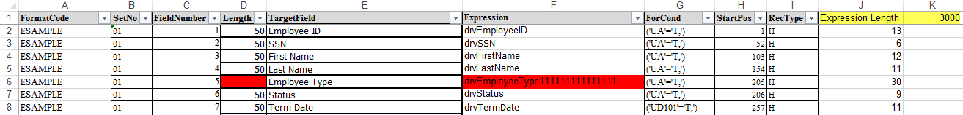

## Notes

* "Length"
  + If the "Length" field is Blank, then the field will highlight in **RED**.
* "RecType"
  + If the "SetNo" between 01 and 09, then default to 'H' (Header)
  + If the "SetNo" between 10 and 89, then default to 'D' (Detail)
  + If the "SetNo" between 90 and 99, then default to 'T' (Trailer)
* "ForCond"
  + If the "Expression" is Blank, then default to ('SS'='T,') for Space Fill.
  + If the "Expression" does not begins with "drv", then default to ('DA'='T,') for hard-coded value.
  + If the "Expression" begins with "drv", then default to ('UA'='T,') for UltiPro table column.
  + If the "Expression" contains "date", then default to ('UD101'='T,') for Date Formatting based on 'DateStyle' in U_dsi_SQLCode tab.
* "Expression Length"
  + This field will display the length of the value in the "Expression" column.
  + If the "Expression Length" is greater than 29 characters, then the field will highlight in **RED**.
* Max File Length
  + The Max File Length will be automatically generated by rounding up to the nearest 1,000 and set as the 'FileLength' in U_dsi_SQLCode tab.

# U_dsi_Configuration Tab – New Features

The Configuration Types in this tab are the values that will be inserted into the dbo.U_dsi_Configuration. These values work in conjunction with the switchbox_v2 and will affect how the Custom Interface functions and generates files.

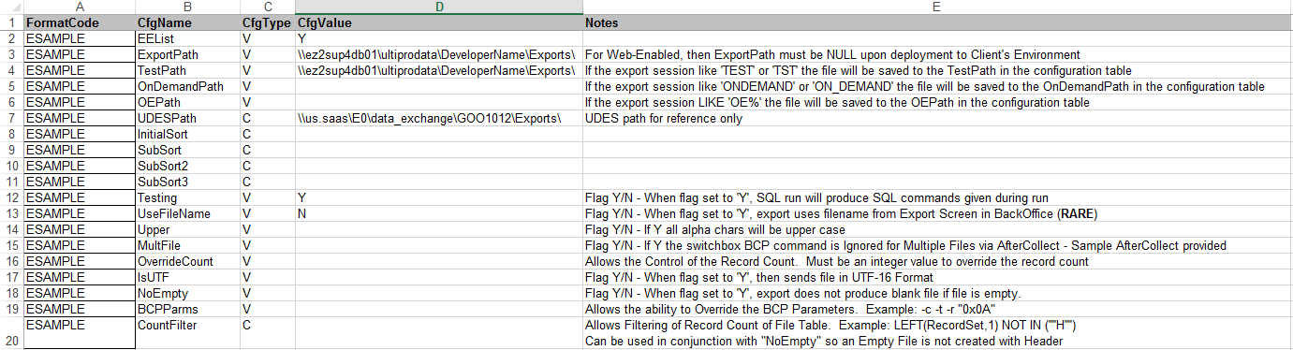

## Notes

* "EEList"
  + If this Flag is Set to "Y", then the dbo.U_FORMATCODE_EEList table will be created. Otherwise it will not be created dynamically.
* "ExportPath"
  + This will defaault to "\\ez2sup4db01\ultiprodata\[Name]\Exports\" where [Name] is set in 'FolderName' in U_dsi_SQLCode tab.
* "TestPath"
  + This is an optional field that is used for the file generation in the BCP statement for Export Session contains "TEST" or "TST".
* "OnDemandPath"
  + This is an optional field that is used for the file generation for Export Session called "ONDEMAND", or "ON_DEMAND".

## Notes (Continued)

* "OEPath"
  + This is an optional field that is used for the file generation for Export Session that start with "OE".
* "UDESPath"
  + This is an optional field that is used mainly for reference, which is automatically generated for 'UltiPro BackOffice' based on the 'SaaSServer'.
* "InitialSort"
  + This is an optional field that is used for the Initial Sorting of the File.
* "SubSort", "SubSort2", "SubSort3"
  + This is an optional field that is used for the Sub Sorting of the File. The "SubSort2" and "SubSort3" allow for 100 character fields to sort.
* "Testing"
  + This is a required field that is used to reference if the Custom Inteface is in Testing or Production.
* "UseFileName"
  + For 'UltiProWeb', this is defaulted to 'Y'. For 'UltiPro BackOffice', this is defaulted to 'N'.
* "Upper"
  + This is an optional field that will convert all characters to Upper Case.
* "MultiFile"
  + This is an optional field that will ignore the Switchbox_v2 BCP statement. If this Flag is Set to "Y", then sample AfterCollect code provided.
* "OverrideCount"
  + This is an optional field that will Override the Record Count shown in UltiPro BackOffice.
* "IsUTF"
  + This is an optional field that will generate the file in UTF-16 Format in the BCP statement.
* "NoEmpty"
  + This is an optional field that will not generate a file if it’s empty.
* "BCPParms"
  + This is an optional field that will allow an override of the Switchbox V2 BCP command parameters.
* "CountFilter"
  + This is an optional field that will allow to filter Record Count of the _File table.

# U_dsi_SQLClauses Tab – New Features

There has not been any New Features added to the U_dsi_SQLClauses Tab. The functionality remains the same as in InterfaceLoader version 1 and 2.



## Notes

* "FormatCode"
  + This field is auto-populated when the U_dsi_SQLCode Tab was populated in the [A2] Cell.
* "RecordSet"
  + This field must be populated for any Record Sets that were identified in the U_dsi_FieldDefs tab.
  + The "RecordSet" is a concatenation of the "RecType" and "SetNo" fields in the U_dsi_FieldDefs tab.
* "FromClause"
  + This field is the name of the Driver Table that will be used to store information to be used by the U_dsi_FieldDefs tab fields.
* "WhereClause"
  + This field will filter information in the file with the use of a WHERE Clause the table specified in the "FromClause".

# U_dsi_AuditRecs – New Tab and Features

The U_dsi_AuditRecs Tab is a New Feature that will allow you to populate a simple table with the Audit Table Name and Audit Field Name. When the BuildDriverTable code is generated, it will automatically code the Audit Fields and Audit Code, which can then later be modified as needed.

The information populated in the Excel sheet is stored in the dbo. U_dsi_AuditRecs table in the Data Services Desktop Environment only.

## Sample Excel File

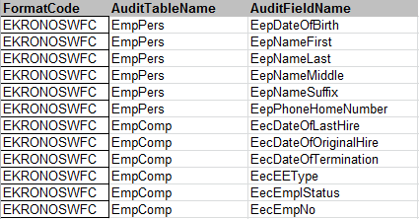



## Sample Auto-Generated Code

--==========================================

-- Audit Section

--==========================================

-- Get data from audit fields table. Add fields here if auditing

IF OBJECT_ID('U_EKRONOSWFC_AuditFields') IS NOT NULL

DROP TABLE dbo.U_EKRONOSWFC_AuditFields;

CREATE TABLE dbo.U_EKRONOSWFC_AuditFields (aTableName varchar(30),aFieldName varchar(30))

INSERT INTO dbo.U_EKRONOSWFC_AuditFields VALUES ('EmpPers','EepDateOfBirth');

INSERT INTO dbo.U_EKRONOSWFC_AuditFields VALUES ('EmpPers','EepNameFirst');

INSERT INTO dbo.U_EKRONOSWFC_AuditFields VALUES ('EmpPers','EepNameLast');

INSERT INTO dbo.U_EKRONOSWFC_AuditFields VALUES ('EmpPers','EepNameMiddle');

INSERT INTO dbo.U_EKRONOSWFC_AuditFields VALUES ('EmpPers','EepNameSuffix');

INSERT INTO dbo.U_EKRONOSWFC_AuditFields VALUES ('EmpPers','EepPhoneHomeNumber');

INSERT INTO dbo.U_EKRONOSWFC_AuditFields VALUES ('EmpComp','EecDateOfLastHire');

INSERT INTO dbo.U_EKRONOSWFC_AuditFields VALUES ('EmpComp','EecDateOfOriginalHire');

INSERT INTO dbo.U_EKRONOSWFC_AuditFields VALUES ('EmpComp','EecDateOfTermination');

INSERT INTO dbo.U_EKRONOSWFC_AuditFields VALUES ('EmpComp','EecEEType');

INSERT INTO dbo.U_EKRONOSWFC_AuditFields VALUES ('EmpComp','EecEmplStatus');

INSERT INTO dbo.U_EKRONOSWFC_AuditFields VALUES ('EmpComp','EecEmpNo');

-- Create audit table based on fields defined above

IF OBJECT_ID('U_EKRONOSWFC_Audit') IS NOT NULL

DROP TABLE dbo.U_EKRONOSWFC_Audit;

SELECT

audEEID = audKey1Value, audKey2 = audKey2Value, audKey3 = audKey3Value, audTableName, audFieldName

,audAction, audDateTime, audOldValue, audNewValue

INTO dbo.U_EKRONOSWFC_Audit

FROM dbo.U_EKRONOSWFC_EEList WITH (NOLOCK)

JOIN dbo.U_EKRONOSWFC_AuditFields WITH (NOLOCK)

ON 1 = 1

JOIN dbo.vw_AuditData (NOLOCK)

ON audKey1Value = xEEID

AND audDateTime BETWEEN @StartDate AND @EndDate

AND audTableName = aTableName

AND audFieldName = aFieldName

AND ISNULL(audNewValue,'') <> '';

# U_dsi_BDMConfigs – New Tab and Features

The U_dsi_BDMConfigs Tab is a New Feature that will allow you to populate a simple table with the BDM Configurations. When the BuildDriverTable code is generated, it will automatically code the BDM Configurations, which can then later be modified as needed.

The information populated in the Excel sheet is stored in the dbo. U_dsi_BDMConfigs table in the Data Services Desktop Environment only.

## Sample Excel File

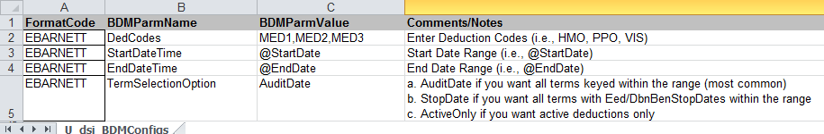

## Sample Auto-Generated Code

--===================================================

-- BDM Section

--===================================================

DELETE FROM dbo.U_dsi_bdm_Configuration WHERE FormatCode = @FormatCode;

-- Required parameters

INSERT INTO dbo.U_dsi_bdm_Configuration VALUES (@FormatCode,'DedCodes','MED1,MED2,MED3');

INSERT INTO dbo.U_dsi_bdm_Configuration VALUES (@FormatCode,'StartDateTime',@StartDate);

INSERT INTO dbo.U_dsi_bdm_Configuration VALUES (@FormatCode,'EndDateTime',@EndDate);

INSERT INTO dbo.U_dsi_bdm_Configuration VALUES (@FormatCode,'TermSelectionOption','AuditDate');

-- Run BDM

EXEC dbo.dsi_bdm_sp_PopulateDeductionsTable @FormatCode;